Finding the Minimum Perceivable Size of a Tactile Element on an Ultrasonic Based Haptic Tablet

【Summary】：

In this study we have performed two psychophysical experiments on an ultrasonic haptic tablet, in order to ﬁnd the minimum size of a tactile element on which all the users are able to perfectly identify diﬀerent types of textures. We use these textures in a second experiment, and evaluate minimal spatial area on which the chosen set of textures can be recognized. Among other, we ﬁnd the minimal size depends on the texture nature.

【Experiments】：

**Apparatus：**

We used a haptic tablet based on ultrasonic vibrations for texture rendering [11] which is developed on a Banana Pi, a single-board computer with 1 GHz ARM Cortex-A7, dual-core CPU and 1 GB of RAM working in parallel with STM32f4 microcontroller.

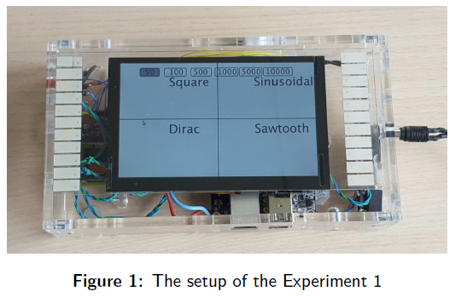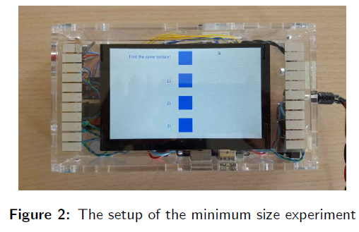

**Experiment 1: Finding the Three Perceivable and Distinguishable Textures：**

At ﬁrst we have done an experiment in order to ﬁnd at least 3 diﬀerent textures that could be perceived and distinguished properly by all users. We have selected 3 types of textures due to the time constraints for performing the two experiments by participants.

Results：

The analysis of results as we can see in table 1, show that several participants could distinguish between 5 to 7 diﬀerent textures. In overall the results demonstrate that all 100% of participants could perceive and distinguish the following textures perfectly: square texture, sinusoidal texture and dirac texture.

**Experiment 2: Finding the Minimum Size of a Tactile Element:**

The goal of our second experiment is to determine the minimum size of a haptic element on a touch screen.

Results：

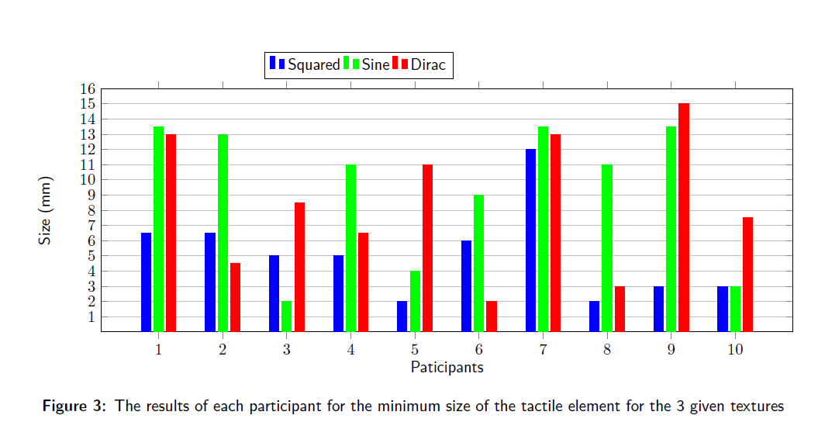

【Conclusion】：

Our results show that the minimum perceivable size of the tactile element depends on the nature of texture signal waveform. The standard range in our case is from few millimeters to about one centimeter, depending on the texture waveform. Our results also demonstrate that the textures with square signal might be more perceivable with small sizes (6.5 mm for the majority of the participants).

【Subjective view】：

The minimum recognition range of different shapes can be studied later.